  LOGO | THE SIVAKASI LIONS VISION ACADEMY  SENIOR SECONDARY SCHOOL – CBSE

Name: _______________________________ | Date: _______________

Grade: 9 Social Science Term: 1
Worksheet No. 1 / Chapter 2 – Shaping of the Earth's Surface

I. Choose the correct option.
1. The outermost layer of the Earth is called:
a. Core b. Mantle c. Crust d. Lithosphere

2. Which type of plate boundary is formed when two plates move away from each other?
a. Convergent b. Divergent c. Transform d. Subductive

3. The wearing away of the Earth's surface by natural agents such as wind, water and ice is known as:
a. Weathering b. Erosion c. Deposition d. Sedimentation

4. Which of the following is an agent of gradation?
a. Volcanoes b. Earthquakes c. Glaciers d. Plate tectonics

5. Landslides are most likely to occur in regions with:
a. Flat plains b. Steep slopes and heavy rainfall c. Desert conditions d. Coastal lowlands

6. The sudden shaking of the Earth's crust caused by the movement of tectonic plates is called:
a. Tsunami b. Volcano c. Earthquake d. Landslide

II. Fill in the blanks.
1. The process by which rocks are broken down into smaller particles by natural forces is called _______________.

2. Mountains formed due to the folding of rock layers are called _______________ mountains.

3. The _______________ is the thickest internal layer of the Earth, made of semi-molten rock.

4. A sudden large movement of snow, ice, and debris down a mountain slope is called a(n) _______________.

III. Write 'T' for true statements and 'F' for false ones.
1. The inner core of the Earth is in a liquid state. _______________

2. Wind is an agent of gradation that can shape landforms in desert regions. _______________

3. Convergent plate boundaries cause the formation of deep ocean trenches and fold mountains. _______________

4. Plains are formed only by the action of glaciers. _______________

5. A Glacial Lake Outburst Flood (GLOF) is caused by the sudden release of water from a glacial lake. _______________

IV. Answer in one or two words / one sentence each.
1. Name the two main forces that shape the Earth's surface.

2. What is a plateau?

3. Name one example of a fold mountain range in India.

4. What does GLOF stand for?

5. Which agent of gradation is responsible for the formation of 'mushroom rocks'?

V. Answer the following questions in 3–4 sentences each.
1. Explain the theory of plate tectonics and name the three types of plate boundaries.

2. What is weathering? Distinguish between mechanical and chemical weathering with one example each.

3. Describe how rivers shape the Earth's surface. Mention any two landforms created by river action.

4. What are the causes and effects of landslides? Name two states in India that are highly vulnerable to landslides.

5. Differentiate between endogenic and exogenic forces with two examples each.

VI. Read the passage and answer the questions that follow.
Case Study 1:
The Himalayan region witnessed heavy rainfall in June 2023. The combination of steep slopes, loosely bound soil, and excessive water saturation led to a massive landslide in the Joshimath area of Uttarakhand. Several roads were blocked, homes were destroyed, and people had to be evacuated. Geologists warned that the region is sitting on unstable geological formations and frequent human interference such as construction of roads and buildings is weakening the slopes further.
1. What natural factors mentioned in the passage contributed to the landslide?

2. What human activities are making the slopes more vulnerable?

3. Suggest any two measures that can reduce the risk of landslides in such regions.

Case Study 2:
Rajasthan's Thar Desert is shaped largely by the action of wind. Strong winds carry fine sand particles and deposit them in the form of sand dunes. Over years, the shape of these dunes changes as wind direction shifts. Hard rocks in the desert are eroded into unusual shapes — with the bottom narrower than the top, resembling a mushroom. Scientists have observed that the desert is slowly advancing southward due to deforestation and overgrazing, a process called desertification.
4. Which agent of gradation is described in the passage? Name two landforms it creates.

5. What human activities are causing the desert to advance? What is this process called?

VII. Map Skills — On the given outline map of India, mark and label the following.
1. Any two fold mountain ranges in India (e.g., Himalayas, Aravallis).

2. Any two major peninsular plateaus (e.g., Deccan Plateau, Chhota Nagpur Plateau).

3. Any two large plains formed by river action (e.g., Indo-Gangetic Plain, Brahmaputra Plain).

4. Any two states in India that are highly prone to earthquake or landslide hazards.

5. The direction of flow of any two major rivers that contribute to the formation of alluvial plains.

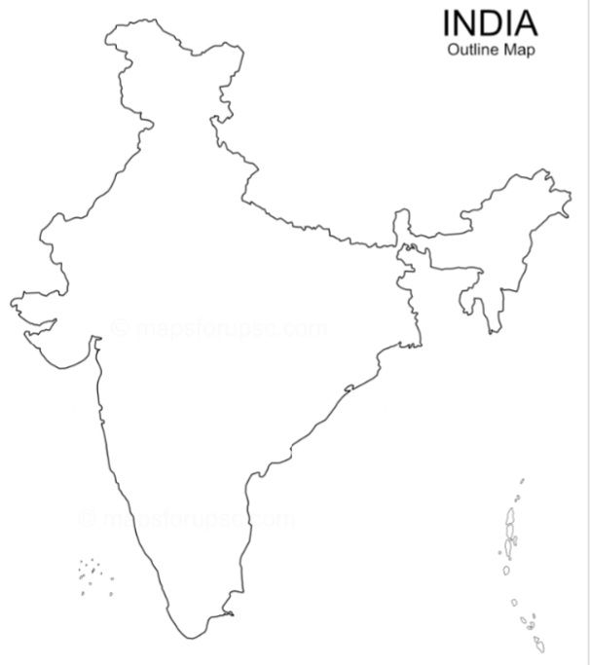

─── All the Best! ───

